**Screens Shots**

**User Module**

**5.2.1 Login page:**

This is the first page of the app And it allows user to login/register into the Online secure cab Booking Environment.

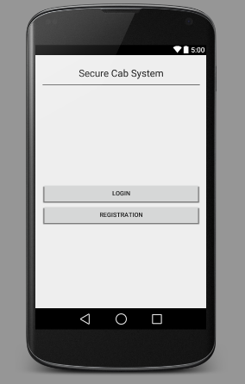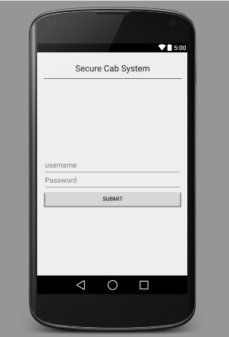

After User selects login page the second screen will be displayed to give user name and password.

**5.2.2 User Registration:**

If the customer is new to the system then he can register through this page which contains fields like name, password, address, email, phone numbers etc.

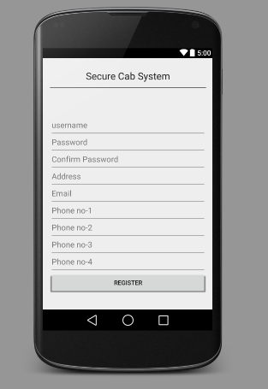

**5.2.3 Travellingdetails:**

After login process successfully completed then customer is navigated to travelling details page In this he canenter the travel details like source and destination so that the journy time,distance and route path are displayed to the user .

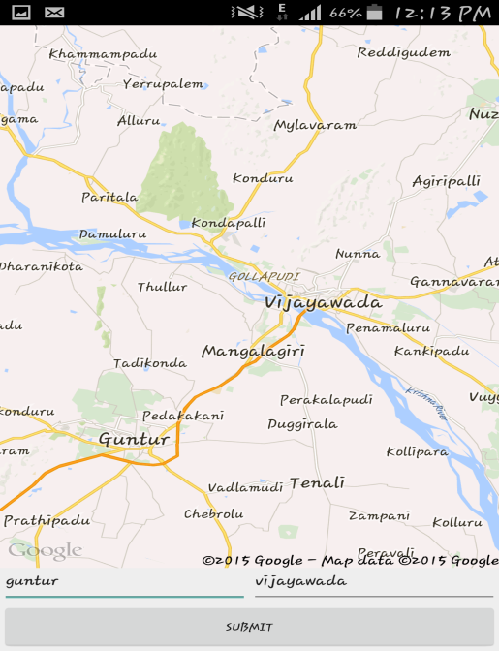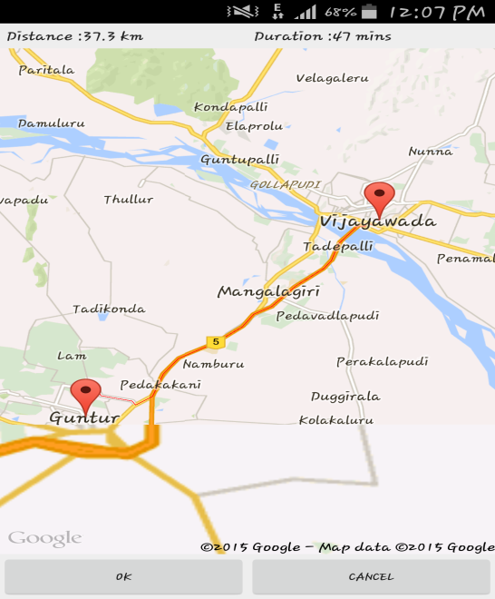

**5.2.4 Current Location:**

If the Customer press ‘OK’ button then his information will sent to the company admin i.e. name,source address,destination address,Email etc.Then the adminwill sent the booking details and after that customer is navigated to next page which contains current location of the user and problem,safely,alarm buttons which enables user to give his status.

If there is any problem occures then problem button useful to send current location to the priority numbers.SetAlarm enables user to set the alarm to perticuler time.

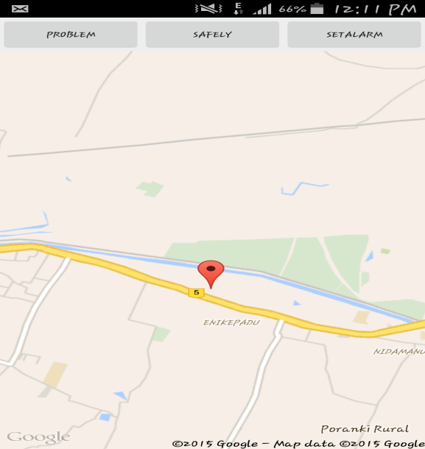

**5.2.5 Company Login:**

Through this company admin can login to the website to do his tasks.

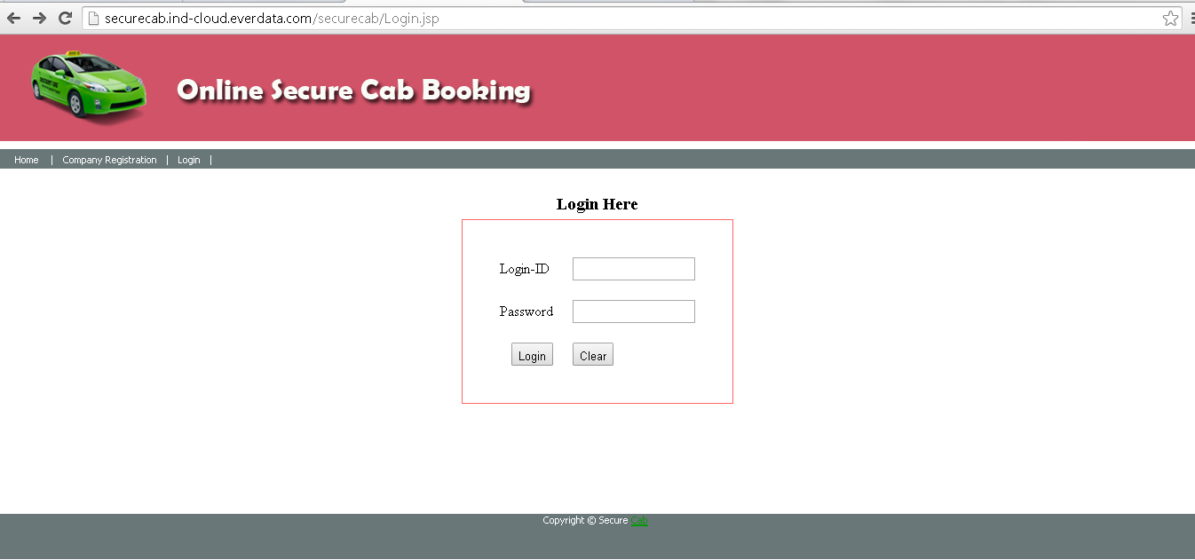

**5.2.6Add Driver:**

Through this admin can add the driver details like id, photo, name, address etc. to the company.

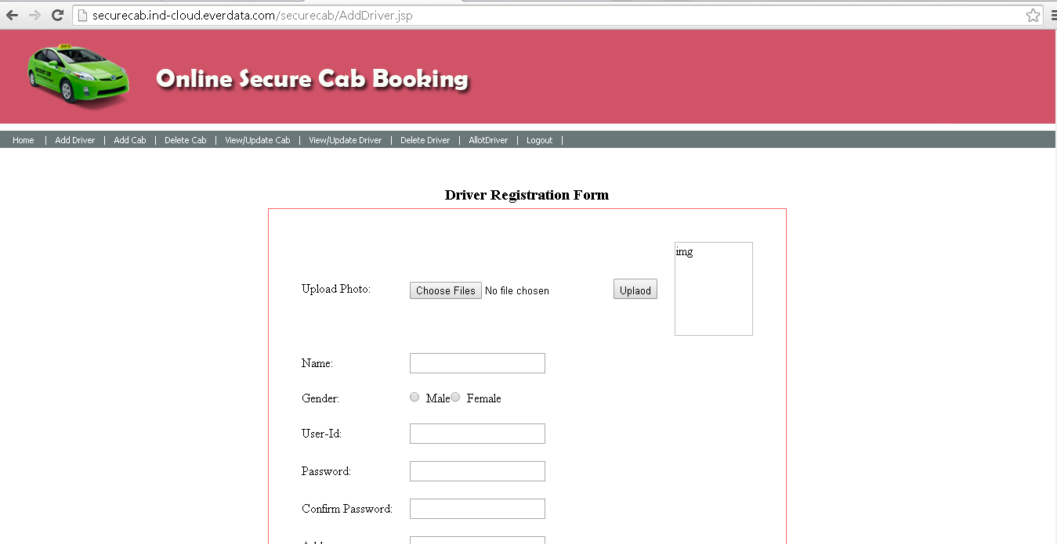

**5.2.7 Add Cab:**

This page is used to add the extra or new cab details to the company.

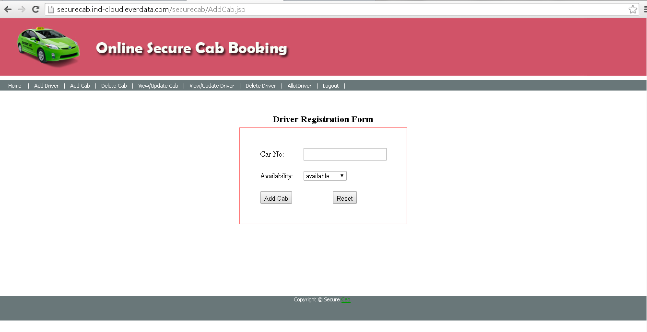

**5.2.8View/Update Cab:**

This enables admin to update the cab details by basing on the availability.

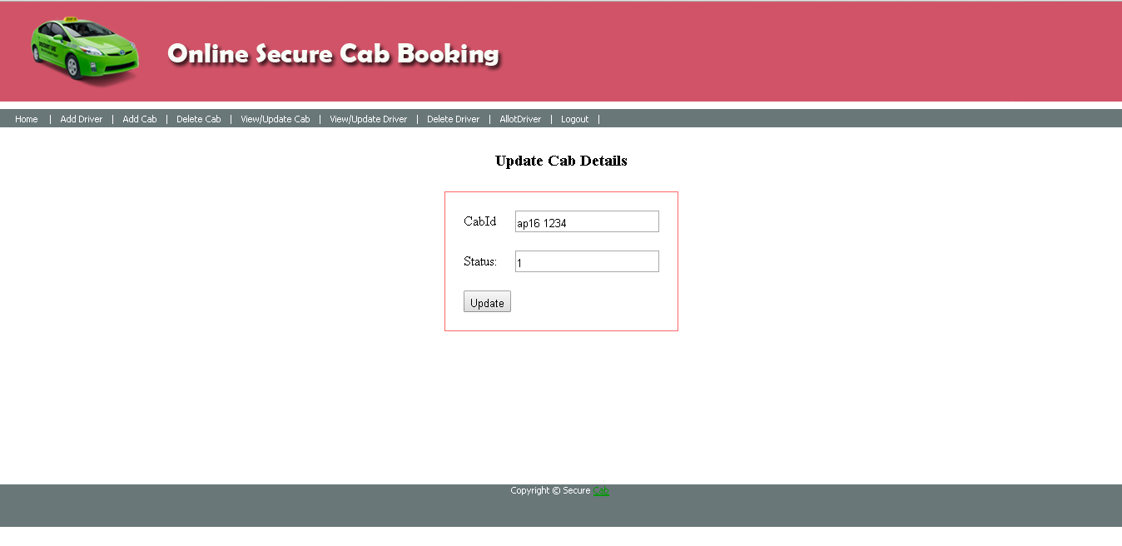

**5.2.9 Allot Cab:**

This provides main functionality to the customer. Through this company admin can allocate the driver after verifying the customer details.

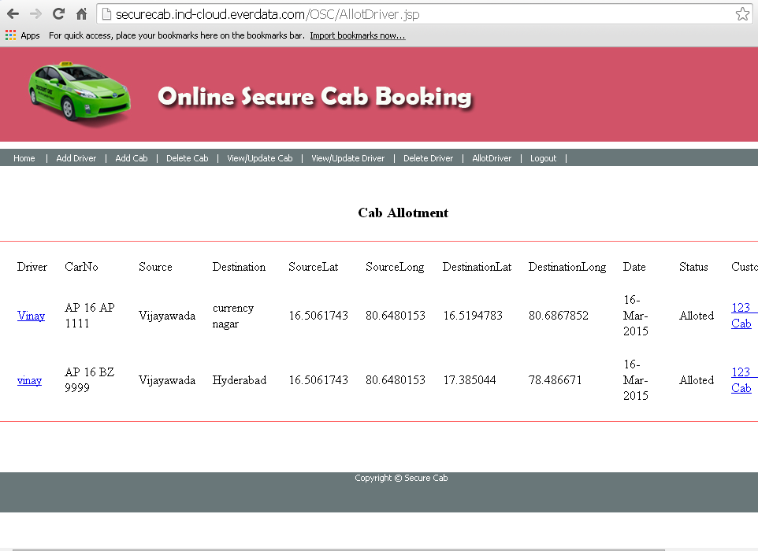

**5.2.10View/Update Driver:**

Through this admin can update the details of driver based on availability of driver and cab.

